Practice for Chapter 6 Section 1. Name: __________________________________________
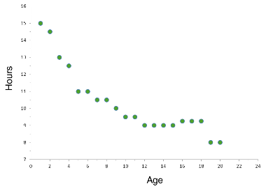
- Below is a scatterplot that compares Age to how many hours of sleep are recommended.

Complete the following for this scatterplot:
- Draw a line of best fit
- Describe the Association, Form, Strength, etc of the graph.
- What is the equation of your line of best fit?
- Interpret the meaning of the slope of your line of best fit.
- Interpret the y intercept.
- What are the residuals for Ages: 4, 10, and 19?

- Consider the data below
Study Hours | 3 | 5 | 2 | 6 | 7 | 1 | 2 | 7 | 1 | 7
Scores on Test | 80 | 90 | 75 | 80 | 90 | 50 | 65 | 85 | 40 | 100
  - Create a scatterplot of this data
  - Does this data represent a function? Justify your answer.
  - Find the line of best fit
  - Describe the association, form, strength, etc of the graph.
  - What is the equation of your line of best fit?
  - Interpret the meaning of the slope and y intercepts
  - What is the residual for 6 hours of sleep?

